|  |
| --- |
| Institute of Technology Carlow, Kilkenny Road, Carlow, Co. Carlow |
| Scrabble Engine |
| Design Manual |

|  |
| --- |
| Keith Byrne, Liam Strevens  01 December 2015 |



Table of Contents

1 Introduction 3

2 Data Model 3

3 Functional Design 3

3.1 Use Cases 3

3.2 Class Diagram 4

3.3 System Sequence Diagrams 5

3.3.1 Login 5

3.3.2 Logout 6

3.3.3 View Scores 7

3.3.4 Submit Word 8

3.3.5 Sign Up 9

3.3.6 Set Difficulty 10

3.3.7 Place Tile 11

3.3.8 Start Game 12

# Introduction

Before attempting any to tackle any code based elements of the project, it is important to consider how to approach the design of the system from a pattern oriented view and how data will be stored. As the system also acts a benchmarking tool to evaluate performance of varying algorithms. This document will included results obtained from comparisons made during the life cycle of the project. This document will be composed iteratively as results are discovered and conclusions are made.

# Data Model

# Functional Design

## Use Cases

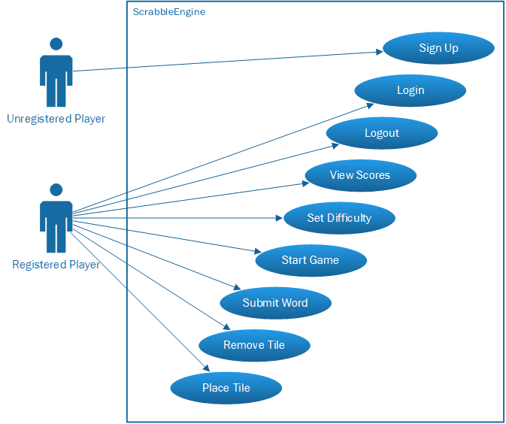

## Class Diagram

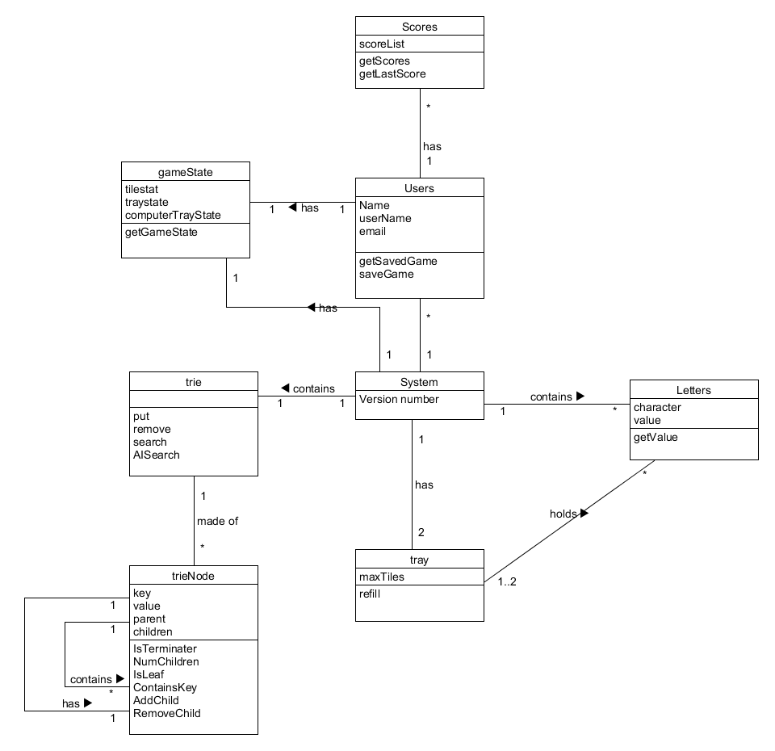

## System Sequence Diagrams

### Login

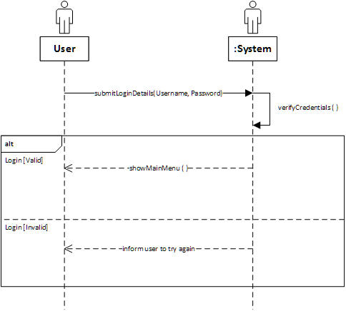

### Logout

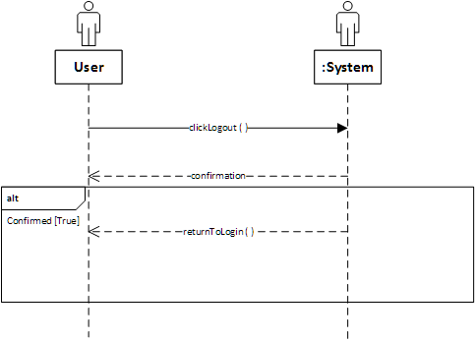

### View Scores

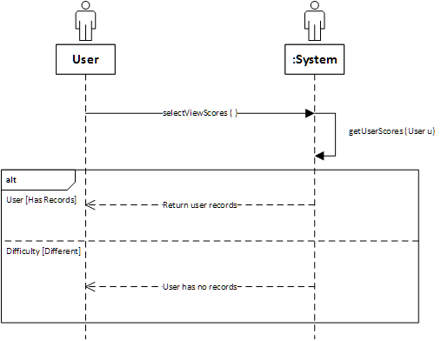

### Submit Word

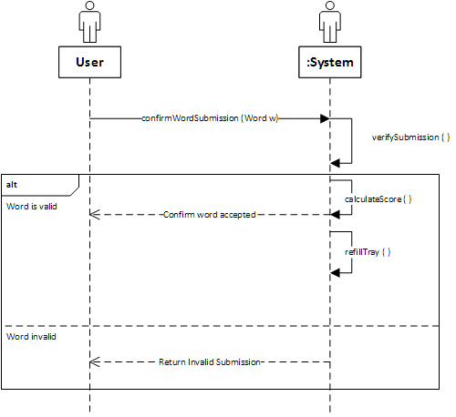

### Sign Up

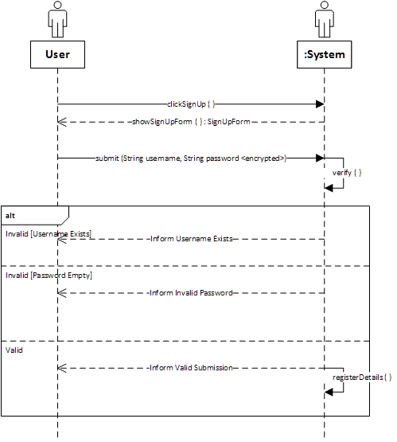

### Set Difficulty

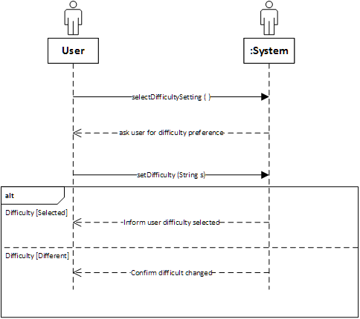

### Place Tile

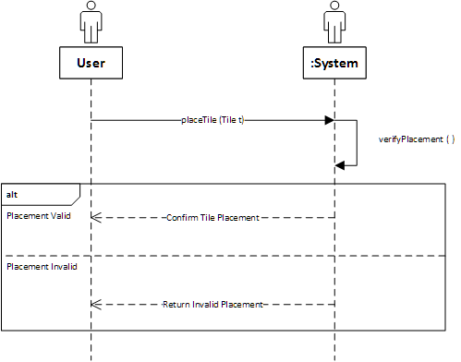

### Start Game

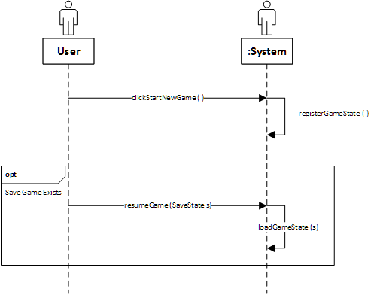

# Graphic User Interface (Core Components)

## Login

### Design (Presentation)

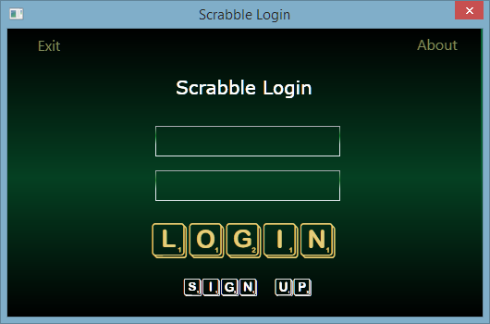

### Design (XAML)

<Window x:Class=**"Scrabble.Login"**

xmlns=**"http://schemas.microsoft.com/winfx/2006/xaml/presentation"**

xmlns:x=**"http://schemas.microsoft.com/winfx/2006/xaml"**

Title=**"Scrabble Login"** Height=**"350"** Width=**"530.352"** ResizeMode=**"NoResize"**>

<Window.Background>

<LinearGradientBrush EndPoint=**"0.5,1"** MappingMode=**"RelativeToBoundingBox"** StartPoint=**"0.5,0"**>

<GradientStop Color=**"Black"** Offset=**"1"**/>

<GradientStop Color=**"#FF096437"**/>

<GradientStop Color=**"#FF075830"** Offset=**"0.496"**/>

</LinearGradientBrush>

</Window.Background>

<Grid Margin=**"0,0,2,-1"**>

<Grid.Background>

<LinearGradientBrush EndPoint=**"0.5,1"** StartPoint=**"0.5,0"**>

<GradientStop Color=**"Black"** Offset=**"0"**/>

<GradientStop Color=**"Black"** Offset=**"1"**/>

<GradientStop Color=**"#FF054022"** Offset=**"0.516"**/>

</LinearGradientBrush>

</Grid.Background>

<Label x:Name=**"HeaderLogin"** Content=**"Scrabble Login"** HorizontalContentAlignment=**"Center"** Margin=**"10,46,10,0"** VerticalAlignment=**"Top"** Background=**"{x:Null}"** Foreground=**"White"** FontSize=**"20"** FontFamily=**"Verdana"**/>

<Label x:Name=**"LoginTrigger"** Content=**"login"** HorizontalContentAlignment=**"Center"** Margin=**"10,201,10,0"** VerticalAlignment=**"Top"** Height=**"62"** Foreground=**"#FFE6CD79"** FontSize=**"72"** FontFamily=**"./Resources/#ScrambleMixed"** MouseDown=**"ClickLoginTrigger"**/>

<Label x:Name=**"SignupTrigger"** Content=**"sign up"** HorizontalAlignment=**"Left"** HorizontalContentAlignment=**"Center"** Margin=**"10,263,0,0"** VerticalAlignment=**"Top"** Width=**"500"** Height=**"40"** Foreground=**"#FFFFFDFD"** FontSize=**"36"** FontFamily=**"./Resources/#ScrambleMixed"** MouseDown=**"clickSignUp"**/>

<Grid Height=**"101"** Margin=**"10,95,10,0"** VerticalAlignment=**"Top"**>

<PasswordBox x:Name=**"PasswordInputField"** HorizontalAlignment=**"Left"** Margin=**"150,58,0,0"** VerticalAlignment=**"Top"** Width=**"200"** SelectionOpacity=**"0"** Foreground=**"#FFFBF6F6"** Height=**"33"** Background=**"{x:Null}"** FontFamily=**"Verdana"** FontSize=**"20"** ToolTip=**"Enter your Password here"**>

<PasswordBox.BorderBrush>

<LinearGradientBrush EndPoint=**"0,20"** MappingMode=**"Absolute"** StartPoint=**"0,0"**>

<GradientStop Color=**"#FFABADB3"** Offset=**"0.011"**/>

<GradientStop Color=**"#FF2C8D34"** Offset=**"0.536"**/>

<GradientStop Color=**"#FFE3E9EF"** Offset=**"1"**/>

</LinearGradientBrush>

</PasswordBox.BorderBrush>

</PasswordBox>

<TextBox x:Name=**"UsernameInputField"** HorizontalAlignment=**"Left"** Height=**"33"** Margin=**"150,10,0,0"** TextWrapping=**"Wrap"** VerticalAlignment=**"Top"** Width=**"200"** Background=**"{x:Null}"** FontFamily=**"Verdana"** FontSize=**"20"** Foreground=**"White"** ToolTip=**"Insert Username here"**>

<TextBox.BorderBrush>

<LinearGradientBrush EndPoint=**"0,20"** MappingMode=**"Absolute"** StartPoint=**"0,0"**>

<GradientStop Color=**"#FFABADB3"** Offset=**"0.026"**/>

<GradientStop Color=**"#FF19802C"** Offset=**"0.513"**/>

<GradientStop Color=**"#FFE3E9EF"** Offset=**"1"**/>

<GradientStop Color=**"#FF1A9C37"** Offset=**"0.588"**/>

</LinearGradientBrush>

</TextBox.BorderBrush>

</TextBox>

</Grid>

<Label x:Name=**"AboutTrigger"** Content=**"About"** HorizontalAlignment=**"Left"** HorizontalContentAlignment=**"Center"** VerticalAlignment=**"Top"** Foreground=**"#FF808958"** Height=**"40"** Width=**"90"** BorderThickness=**"1"** Margin=**"420,0,0,0"** FontSize=**"16"** RenderTransformOrigin=**"0.5,0.75"** MouseEnter=**"MouseAboutEnter"** MouseLeave=**"MouseLeavel"**/>

<Label x:Name=**"ExitTrigger"** Content=**"Exit"** HorizontalAlignment=**"Left"** HorizontalContentAlignment=**"Center"** Foreground=**"#FF808958"** Width=**"90"** BorderThickness=**"1"** Margin=**"0,1,0,282"** FontSize=**"16"** Height=**"40"**/>

</Grid>

</Window>

## Main

### Design (Presentation)

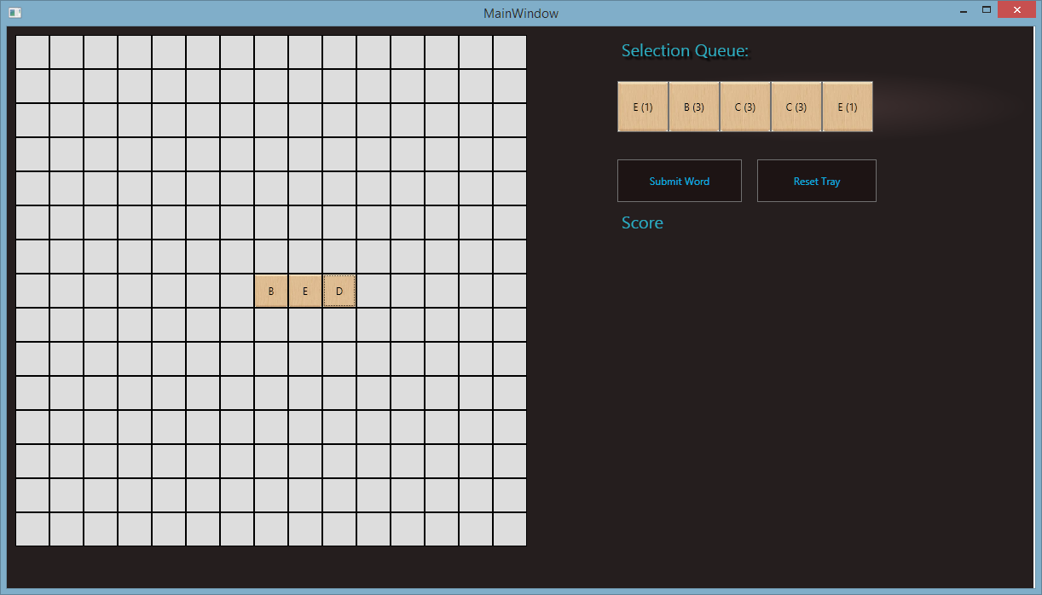

### Design (XAML)

#### Game Board

<Window

xmlns=**"http://schemas.microsoft.com/winfx/2006/xaml/presentation"**

xmlns:x=**"http://schemas.microsoft.com/winfx/2006/xaml"**

xmlns:d=**"http://schemas.microsoft.com/expression/blend/2008"** xmlns:mc=**"http://schemas.openxmlformats.org/markup-compatibility/2006"** mc:Ignorable=**"d"** x:Class=**"Scrabble.MainWindow"**

Title=**"MainWindow"** Height=**"698"** Width=**"1222"**>

<Canvas Margin=**"0,0,2,-21"** Background=**"#FF251E1E"**>

<Label x:Name=**"GameQTrack"** Content=**"Selection Queue: "** Canvas.Left=**"716"** Canvas.Top=**"8"** Width=**"416"** FontSize=**"20"** Foreground=**"#FF2CADC1"** BorderThickness=**"0"**>

<Label.Effect>

<DropShadowEffect BlurRadius=**"3"**/>

</Label.Effect>

</Label>

<Label Content=**"Score"** Canvas.Left=**"716"** Canvas.Top=**"210"** Foreground=**"#FF2CADC1"** FontSize=**"20"**/>

<Button Content=**"Submit Word"** Canvas.Left=**"716"** Canvas.Top=**"156"** Width=**"146"** RenderTransformOrigin=**"0.12,-0.7"** Height=**"50"** Background=**"#FF1D1414"** Foreground=**"#FF0CAEDE"** Click=**"clickSubmitWord"**/>

<StackPanel x:Name=**"PlayerTray"** Height=**"84"** Canvas.Left=**"716"** Canvas.Top=**"52"** Width=**"486"** Orientation=**"Horizontal"** MouseDown=**"returnCharactersToTray"**>

<StackPanel.Background>

<RadialGradientBrush>

<GradientStop Color=**"#FF251E1E"** Offset=**"0.992"**/>

<GradientStop Color=**"#FF251E1E"**/>

<GradientStop Color=**"#FF3A2D2D"** Offset=**"0.23"**/>

</RadialGradientBrush>

</StackPanel.Background>

</StackPanel>

<Button Content=**"Reset Tray"** Canvas.Left=**"880"** Canvas.Top=**"156"** Width=**"140"** Click=**"clickResetTray"** Height=**"50"** Background=**"#FF1D1414"** Foreground=**"#FF0CAEDE"**/>

<WrapPanel x:Name=**"GameBoard"** Height=**"600"** Canvas.Left=**"10"** Canvas.Top=**"10"** Width=**"600"**/>

</Canvas>

</Window>

#### Game Board Generation Sequence

**for** **(**int i **=** 0**;** i **<** 225**;** i**++)**

**{**

**BoardTile** blank **=** **new** **BoardTile();**

blank**.**Tag **=** **new** **GameTile();**

blank**.**Height **=** 40**;**

blank**.**Width **=** 40**;**

**if** **(**i **==** 112**)**

**{**

blank**.**Content **=** "X"**;**

**}**

blank**.**Name **=** "GRID_" **+** **(**i **+** 1**);**

blank**.**id **=** i**;**

blank**.**Click **+=** boardTileListener**;**

GameBoard**.**Children**.**Add**(**blank**);**

**}**